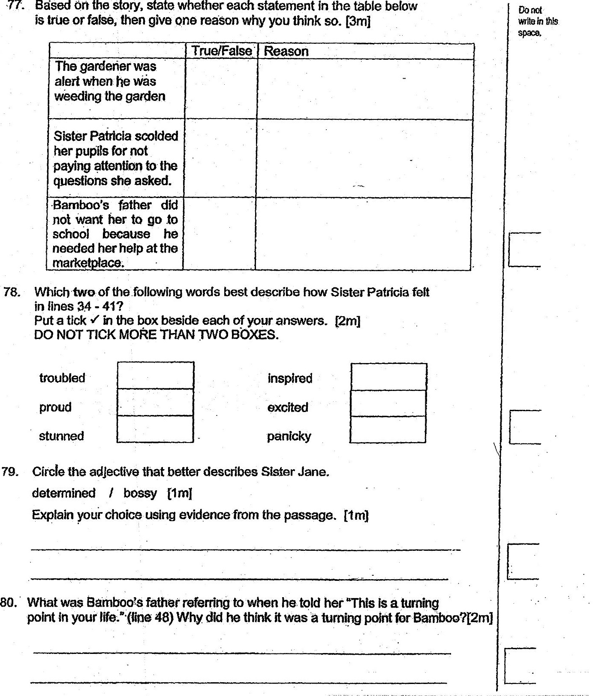

79. Circle the adjective that better describes Sister Jane.  
determined / bossy [tr]  
Explain your choice using evidence from the passage. [tm]